MED D - SilverScript Physician Vaccine Claim Requests

General Inforamtion
Process - Care
Log Activity
Resolution Time
Related Documents

Description: The document provides information on how to assist physicians with vaccine claim requests.

General Information
When the Center for Medicare and Medicaid (CMS) services made changes to the guidance in regard to vaccine administration, physicians began sending claim forms into SilverScript for the vaccine itself as well as for the administration of the vaccine in their office.

On August 16, 2022, the 2022 Inflation Reduction Act (IRA) was signed into law. This law contains many changes to the Medicare program that will take effect starting from October 2022 through 2032. Beginning January 1, 2023, the IRA requires a $0 beneficiary cost-share for adult vaccines recommended by the Advisory Committee on Immunization Practices (ACIP) under Medicare Part D for adults 19 years of age and older. The $0 Part D vaccine IRA provisions do not apply to beneficiaries aged 18 or younger or for any other adult age groups not supported by ACIP recommendations for the vaccine. Refer to MED D - Inflation Reduction Act.

If a covered vaccine under Medicare Part D was dispensed and/or administered by a physician, he/she may collect only the beneficiary’s applicable co-payment. The physician may submit claim(s) for the vaccine as well as the vaccine administration fee to SilverScript Insurance for reimbursement by submitting the Medicare 1500 form. The reimbursement will be based on the cost share of SilverScript.

Note: The form can be found by accessing www.cms.gov.
- Enter “1500 Claim Form” in the search field at the top of the page.
- Click on the ‘Form CMS1500 – Center for Medicare & Medicaid Services’ link to access the form.

- The form on the CMS website is for informational purposes only and is for physician use. CCRs do not have the ability to supply or send the Medicare 1500 claim form.

Example: Medicare 1500 form, Page 1 of 4

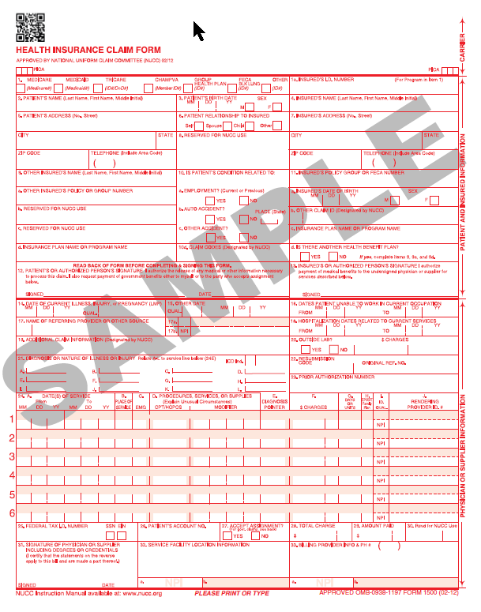

Top of the Document

Process - Care

When addressing Vaccine Claim issues, the CCR will follow the steps outlined below:
Step | Action
1 | Utilize PeopleSafe to view paper claims by selecting the “All” tab on the Participant Inquiry screen.
2 | Determine if information is available on the claim in question.
2 | If… | Then…
2 | No | Proceed to Step 3.
2 | Yes | Proceed to Step 4.
3 | Inform physician or their delegate that claim has not yet been entered in the system.  Before disconnecting with the physician or their delegate, verify the claim form was sent to the correct address:  Caremark Medicare Vaccine Processing  PO Box 52066  Phoenix, Arizona 85072-2066
4 | If the CCR has visibility to the claim in question, inform the physician or their delegate that it has been received and is in process.  If physician or their delegate has questions about reimbursement of the claim, the CCR will utilize the Financial Details screens in PeopleSafe to discuss how the claim paid and what reimbursement was entered. Refer to the ‘Paper Claim Research’ section in Paper Claim Research (Submissions, Locating, Rejections and Reimbursements) to investigate the callers claim.
5 | Determine if the Physician is disputing the claim reimbursement.
5 | If… | Then…
5 | No | Proceed to Step 10.
5 | Yes | Proceed to Step 6.
6 | Complete the following task:  - Task Category: Paper Claims  - Task Type: Participant research Request (CRR)  - Queue: Select the appropriate Platform beneficiary  Notes:  - The Notes section should be specific as to what the physician is disputing.  - Task is only available for Physician submitted vaccine claims.  Example: Physician disputes reimbursement amount or Quantity not entered correctly.
7 | In addition to the Paper Claim task, complete the following task:  - Task Category: Customer Care Internal Process  - Task Type: Participant Callback Request  - Queue: CC Internal Research Nashville
8 | Inform the physician that information has been requested on the claim and it could take up to 21 days for research and callback.
9 | Ask if there are any other benefit questions.
9 | If… | Then…
9 | Yes | Address any benefit issues.
9 | No | Proceed to the next step.
10 | Document and close the call according to current policies and procedures. Refer to the MED D - Call Documentation.

Top of the Document

Log Activity
600 – Claim Pull
601 – Claim Research Request (CCR)
602 – Claim Status

Top of the Document

Resolution Time
21 days for research and callback
Top of the Document

Related Documents
MED D - Researching and Submitting Paper Claims

Parent SOP: CALL-0048: Medicare Part D Customer Care Call Center Requirements-CVS Caremark Part D Services, L.L.C.
Abbreviations/Definitions: Abbreviations / Definitions

Top of the Document

Not to Be Reproduced or Disclosed to Others without Prior Written Approval
ELECTRONIC DATA = OFFICIAL VERSION – PAPER COPY = INFORMATIONAL ONLY

